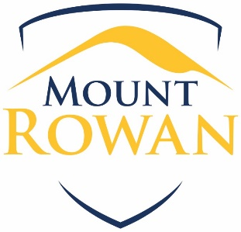 MOBILE PHONES

Purpose
To explain to our school community Mount Rowan Secondary College’s policy requirements, and expectations regarding the safe and appropriate use of mobile phones by students, at school or during school activities.

Scope
This policy applies to all students at Mount Rowan Secondary College.

Policy
At Mount Rowan we have implemented a Personal Electronic Devices Policy.
All Personal Electronic Devices are to be silent and invisible between 8:50 am and 3:15 pm.
This includes recess/lunch.

Personal Electronic devices include: iPods, Mobile Phones, MP3 Players, iPads, Headphones and Portable Bluetooth Speakers.
If a student is seen to have a personal electronic device the following will take place:
- They are to be sent to the front office to hand their phone in.
- At the office upon handing their phone in, they will receive a receipt that they will need to use to collect their phone. Their phone will be locked away for the duration of the day.
- Students can then collect their phone at the end of the day (after 3:15).
If a student refuses to hand their phone in at the office:
- They are to be sent to the student services room. They will receive an external suspension for refusing to follow teacher instructions. The student will be required to hand in their phone. They will then be sent back to class or receive/lunch.
- If a student still refuses to hand in their phone they will spend they receive an internal suspension for the duration of the day (or until they hand their phone in) and an external suspension the following day.

Mobile phone use
Mobile phones must not be used:
- during class or assemblies or in any way that disrupts the learning of others
- to send inappropriate, harassing or threatening messages or phone calls
- to engage in inappropriate social media use including cyber bullying
- to capture video or images of people, including students, teachers and members of the school community without their permission
- to capture video or images in the school toilets, changing rooms and gym.
Students who use their mobile phone inappropriately at school may be issued with consequences consistent with our school’s Student Wellbeing and Engagement and/or Bullying policies.
If students are observed using their phone incorrectly their phone may be confiscated and placed in the locked safe at the General Office until the end of that school day.

Insurance
Students are responsible for their mobile phone. Please note that the Mount Rowan Secondary College does not have accident insurance for accidental property damage. Students and their parents/carers are encouraged to obtain appropriate insurance for valuable items, including mobile phones that may be brought to school. Students are responsible for items brought to school.

Camps and excursions
In most circumstances, students will not be allowed to bring their mobile phones on overnight school camps or excursions. Mount Rowan Secondary College will provide students and their parents and carers with information about items that can be brought to special activities and events, including mobile phones on a case by case basis.

Related policies and resources
- Mount Rowan Student Wellbeing and Engagement Policy
- Mount Rowan Internet Use and Social Media Policy
- School Policy and Advisory Guide: Students Using Mobile Phones

Review period
This policy was last updated on July 2018 and is scheduled for review on May 2020.

